UNIQUE FEATURES OF AYUSH RESEARCH PORTAL
AYUSH RESEARCH PORTAL contains the research data of Ayurveda, Yoga and Naturopathy, Unani, Siddha, Homoeopathy along with AYUSH related research done by the allied sciences. It has mainly two applications.
a. Search of research data by the User
b. Uploading of research data by the selected institutes

Type AYUSH RESEARCH PORTAL URL address (http://ayushportal.nic.in) in address bar
a. Search of research data by the User
i. User can get Clinical research articles for specific disease condition by selecting
>Select medical system> Select body system > Select disease (English)
(Body system and disease conditions are categorized based on ICPC/ICD codes)

ii. User can also get the research articles by simply clicking the following categories

- Clinical Research
(A, B, C gradation was also given to the clinical research articles based on the WHO grading recommendations)
- Pre-Clinical Research
- Drug Research
- Fundamental Research

Number of studies/ data available in each category will also be shown. By clicking this number user can view the research abstracts and also access full paper (where available) by clicking hyperlink.

Further, USER can also search the data by advanced search options viz., Simple Search.

b. Uploading of research data by the selected institutes
To upload the data in the AYUSH RESARCH PORTAL, user has to login by entering the user name and password (which are provided by the NIIMH, Hyderabad to all AYUSH Research Councils & other selected institutes)

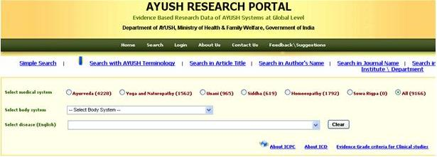

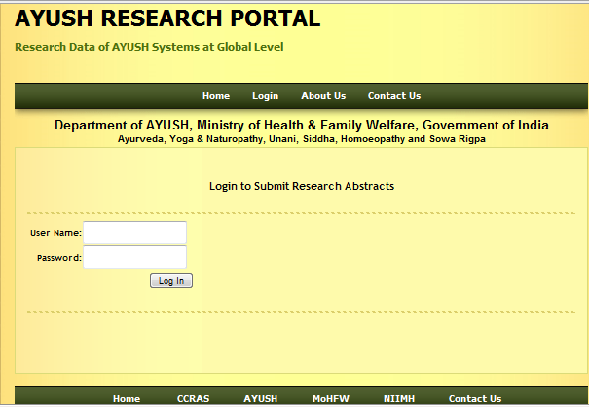

Enter user name, password and click login.

The following window will be opened.

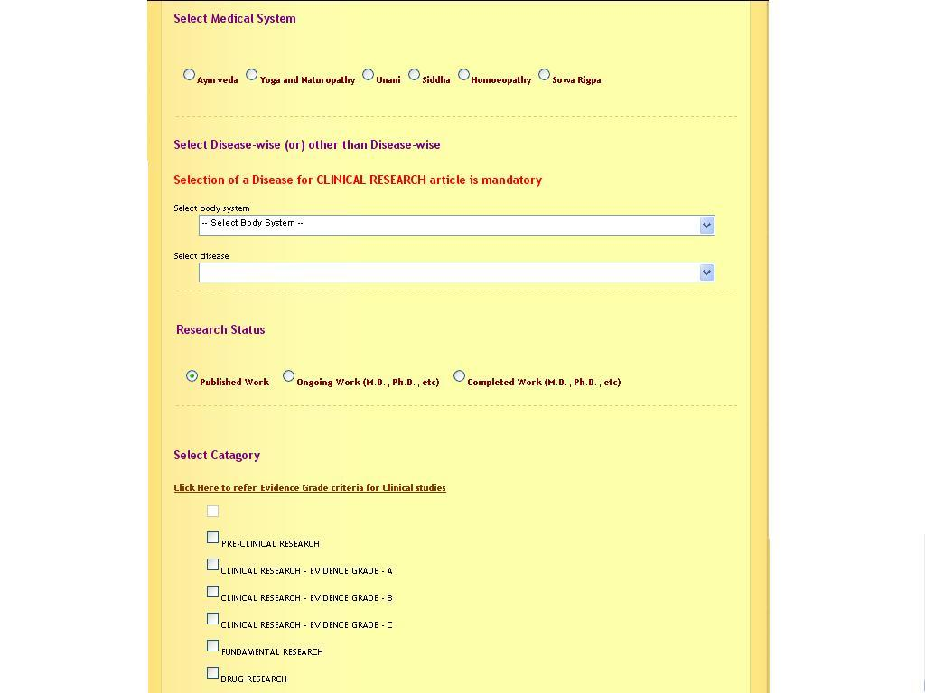
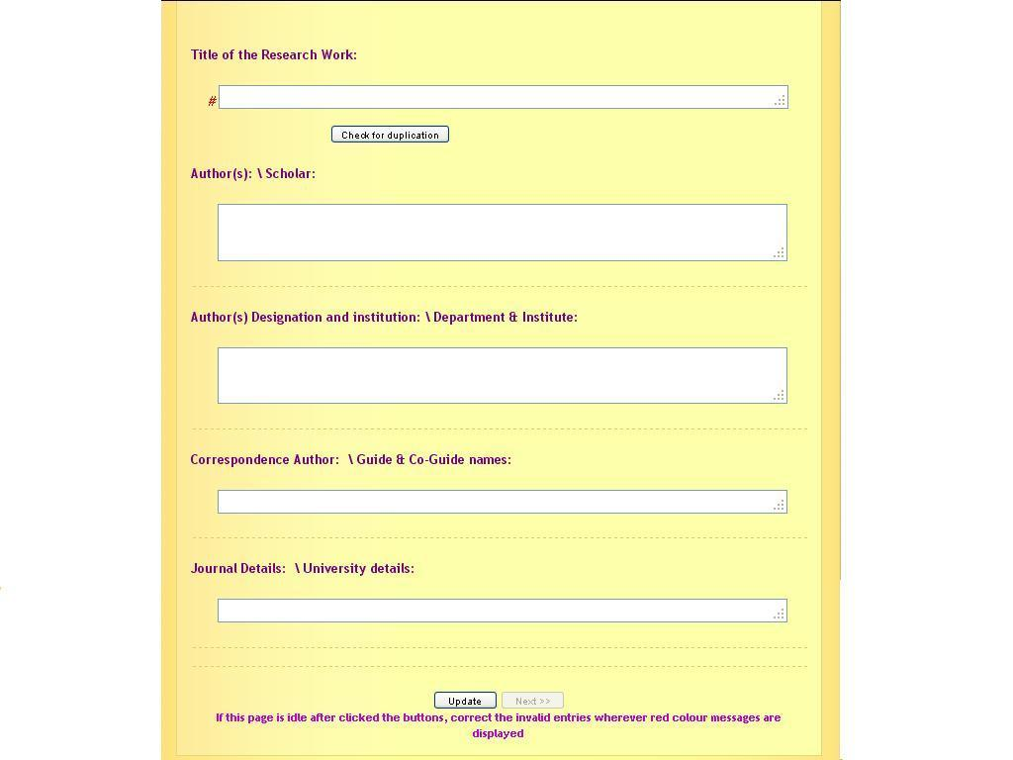

If the uploading data is related to research articles related to clinical research, then follow the below.

Select medical system >Select body system>Select disease> Select Research status>Select suitable category>
(Please see the WHO document on General Guidelines for Methodologies on Research and Evaluation of Traditional Medicine – page 39 & 40 to select category of clinical articles based on level of evidence)

Enter the following
Title of the Research Work > Author(s)> Author(s) Designation and institution> Correspondence Author> Journal Details (in prescribed format – e.g. Journal of Research in Ayurveda and Siddha | Year : 2009 | Volume : 30 | Issue : 1 | Page : 93-106)
* In case of article from online journal (where page nos. are not mentioned), mention as online journal in the field of Page)

Click update

(Data will be saved and article id will be generated (see below). This article id can be used for further reference and for editing, approval process)

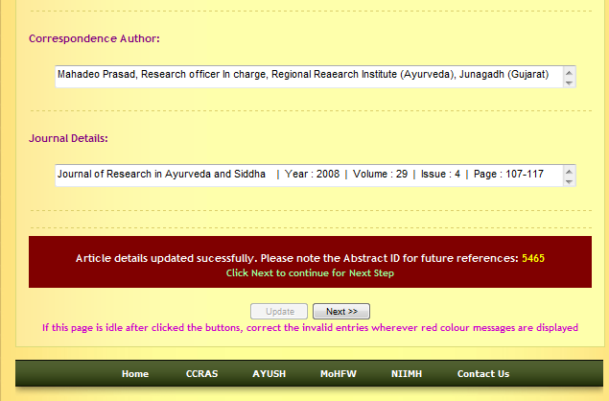

Then click Next >>

The following window will be opened.

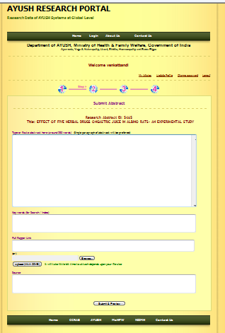

Enter
Abstract > Keywords (appropriate key words may be selected from abstract /title of the article if key words are not provided in article)> URL address (in case, where full paper available in internet) or browse and upload full paper (PDF) if full paper available with the institute>Click upload button.

Once full paper (PDF) is uploaded, the following window open and confirm the successful upload.
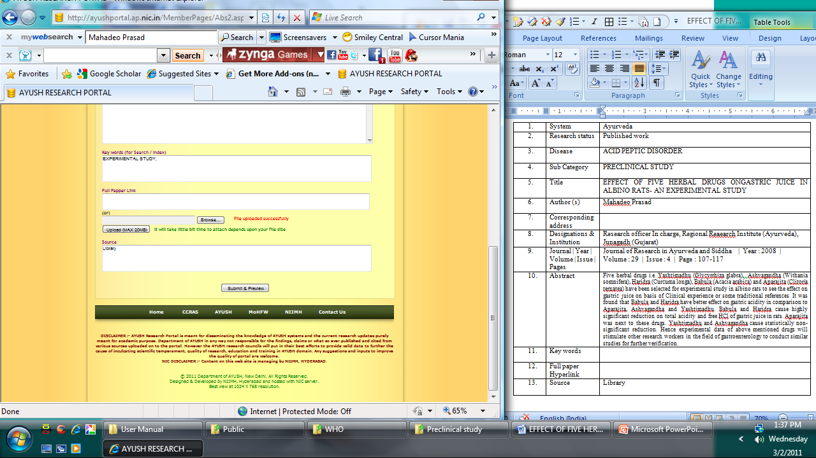

Then Enter
Source of the article (Institute library / URL address in case, article is collected from internet>Click submit & preview.

The following window will be opened and preview of the entered data can be seen.
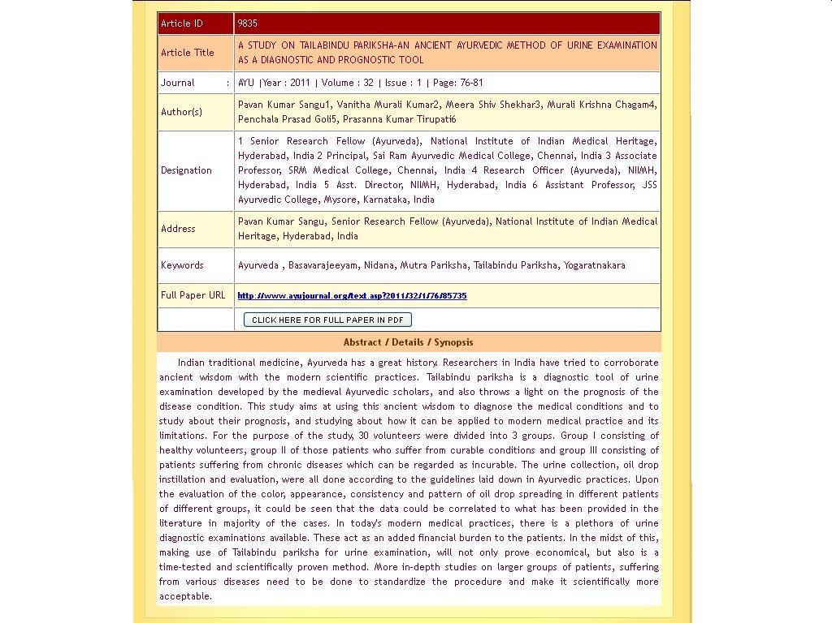

This entered data will be checked and approved after suitable modifications/ corrections by the concerned.

If the uploading data is related to Preclinical Research/ Drug Research/ Fundamental Research…

Select medical system > Select Research status>Select suitable category> …

Then, enter the following

Title of the Research Work > Author(s)> Author(s) Designation and institution> Correspondence Author> Journal Details

Rest of the procedure is as similar to the Clinical Research data upload.
DATA ENTRY AND APPROVAL SYSTEMS

Each AYUSH Research Council has constituted AYUSH Research Portal Committees to ensure the quality research data in the portal.

- Research articles from various journals are screened and AYUSH related articles are identified.
- The selected articles data is presented in the prescribed format and categorized into above-said four categories.
- These data is circulated to the committees of AYUSH RESEARCH PORTAL for their suggestions/ modifications.
- Finally research data is uploaded in the Research Portal.

NB: CCRAS/NIIMH, Hyderabad will provide user name and password to Research Councils, institutes and other AYUSH universities, institutes, colleges, which are selected by the Department of AYUSH, Government of India.

Further, users are requested to read the ICPC (International Classification of Primary Care- http://www.globalfamilydoctor.com/wicc/pagers/english.pdf), ICD (International Statistical Classification of Diseases and Related Health Problems), General Guidelines for Methodologies on Research and Evaluation of Traditional Medicine - http://whqlibdoc.who.int/hq/2000/WHO_EDM_TRM_2000.1.pdf (page 39 & 40 to understand level of Evidence) documents along with ICPC-ICD table (in excel sheet) for proper understanding and execution of this task.

